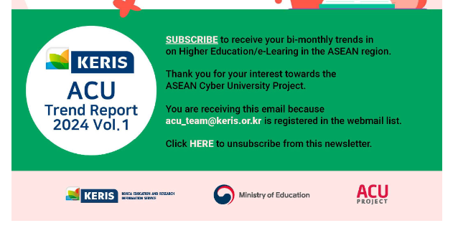

Proposal Template

Thank you very much for your interest towards the ASEAN Cyber University (ACU) Project. Please use the following template to propose your online course to the “Call for Proposal: ASEAN University Online Course utilizing ACU Platform (ACU-LMS).”

You are kindly requested to fill in the first 6 sections as detailed as possible, and use Section 7 to indicate any additional information necessary to share with the ACU Secretariat (KERIS).

Please make sure to submit the followings:
- This completed proposal template
- A sample content (video clip & resource materials) that will be uploaded on the ACU-LMS)

Please kindly submit the completed proposal template with any relevant materials no later than Friday, June 14th, 2024, via e-mail to Ms. Sanghee Kim at shkim@keris.or.kr, and/or ACU Secretariat at acu_team@keris.or.kr. Please also e-mail any questions to the same e-mail.

Final selection will be emailed individually by June 28th, 2024.
We look forward to your active participation!

Section 1. Applicant’s Information
Name
Nationality
Affiliation
Position
Contact | Email
Contact | Telephone
Personal  Information |  | Please freely include any career or experiences you feel are relevant to the KERIS collaboration (ex. Your position and main tasks in the university, your relation with the course for proposal, etc.)
Application background
and Purpose
Section 2. Basic Course Information
Course Title
Course Operation Period
Course Enrollment Period
Learning Type  (please check(∨) one) | Full Online ( ) / Blended ( ) / Flipped ( )
Credit / Non-Credit  (please check(∨) one) | Credit ( # of units ) / Non-Credit ( )
Course Pacing | Instructor-paced ( ) / Self-paced ( )
Course Area | (Ex. Humanities/Social Sciences/Computer Engineering, etc)
Hours of effort per week | ( ) hours
Level of Course | Beginning ( ) / Intermediate ( ) / Advanced ( )
Course Introduction
Learning Objectives
Prerequisite
Textbook & Reference
How to Provide Assistance for Leaners

Section 3. Target Students
Number of Students
Openness | Specific Students ( )  Anyone including Specific Students ( )

Section 4. Course Team

1) Instructor

Name
Affiliation
Specialty
Brief Introduction
Contact (Mail)

2) Teaching Assistant

Name
Affiliation
Specialty
Brief Introduction
Contact (Mail)

Name
Affiliation
Specialty
Brief Introduction
Contact (Mail)

3) Other Support Members

Name
Affiliation
Specialty
Brief Introduction
Contact (Mail)

Section 5. Curriculum and Weekly Contents
# | Topics and activities | Content name and URL | Notes
 |  |  | Example: synchronous lecture, lecture video, discussion, practice (Lab), quizzes, guest lecture, etc.

Section 6. Course Contents License

Category | Check(∨) | Description
Attribution | ( ) | Allow others to copy, distribute, display and perform your copyrighted work but only if they give credit the way you request. Currently, this option is required.
Noncommercial | ( ) | Allow others to copy, distribute, display and perform your work - and derivative works based upon it - but for noncommercial purposes only.
No Derivatives | ( ) | Allow others to copy, distribute, display and perform only verbatim copies of your work, not derivative works based upon it. This option is incompatible with "Share Alike".
Share Alike | ( ) | Allow others to distribute derivative works only under a license identical to the license that governs your work. This option is incompatible with "No Derivatives".

Section 7. Additional Information (Optional)
Please include any other information that you view are relevant to the KERIS proposal
But have not been mentioned in the three sections above.

CERTIFICATION: I hereby certify that, to the best of my knowledge, the provided information is true and accurate.

Applicant’s signature: ____________________________________
Date: ____________________________________

* Should you have any questions, please contact ACU Secretariat by email: shkim@keris.or.kr, and/or acu_team@keris.or.kr.

